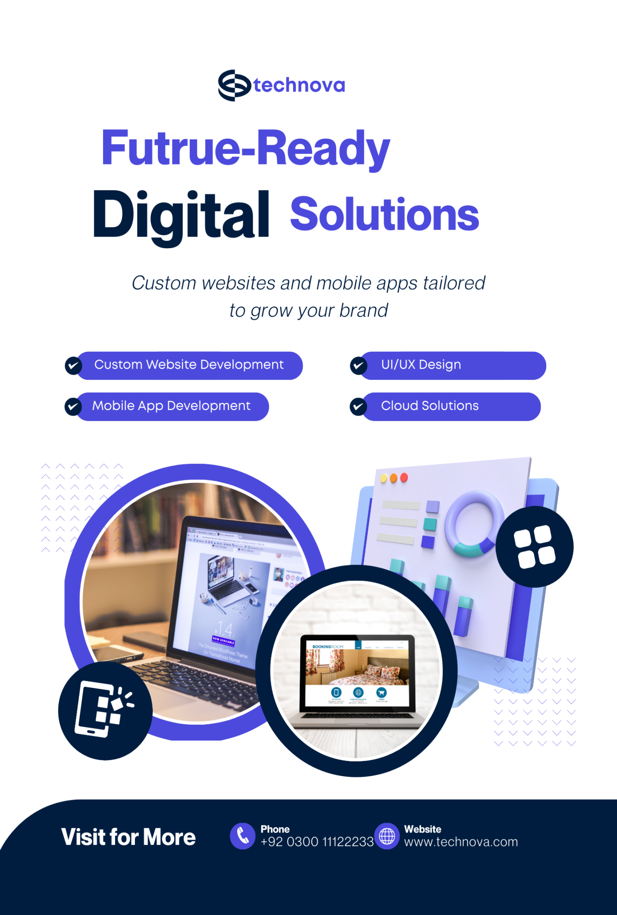

**Project Title:**   
TechNova – Technology Startup Website



**GROUP MEMBERS:**

* Sabeen Waqas – 2025-GA-48
* Iffah Farhan – 2025-GA-32
* Shiza Eman – 2025-GA-58
* Tahira Batool – 2025-GA-44
* Huma Imam – 2025-GA-25

**Course:**   
Applications of Information and Technology (Lab)

**Instructor:**   
Ms. Ramsha Khalid

**Date:**   
06-01-2026

Contents

Executive Summary 4

Project Objectives & Scope 4

Objectives: 4

Scope: 4

Site Structure & Navigation 4

Page Name 4

Purpose 4

Design Choices 6

Color Scheme 6

Typography 6

Layout Consistency 6

Page-Specific Design Considerations 7

Visual Elements 7

User Experience & Responsiveness 7

Assets Used 7

Assets 7

Source 7

How to Run / Publish the Website 8

Steps: 8

Live Website URL: 8

Excel Sheets 8

Reflection 9

LinkedIn Screenshots 10

POWERPOINT KEY SLIDES 13

# Executive Summary

This project presents the design and development of a professional technology startup website named TechNova. The website highlights the startup’s careers and team’s contacts using a modern and responsive design. Supporting data has been documented and quantified using MS Excel to ensure consistency across the website, documentation, and presentations.

# Project Objectives & Scope

## Objectives:

* To design a modern tech startup website
* To present careers and clearly
* To apply structured documentation and data handling

## Scope:

* Static front-end website
* Includes Home, About, Careers and Contact pages
* Uses mock business data
* No backend or live transactions

# Site Structure & Navigation

| Page Name | Purpose |
| --- | --- |
| Home | Startup introduction and highlights |
| Careers | Display tech services offered |
| About Us | Company vision and team |
| Contact | Contact form and details |

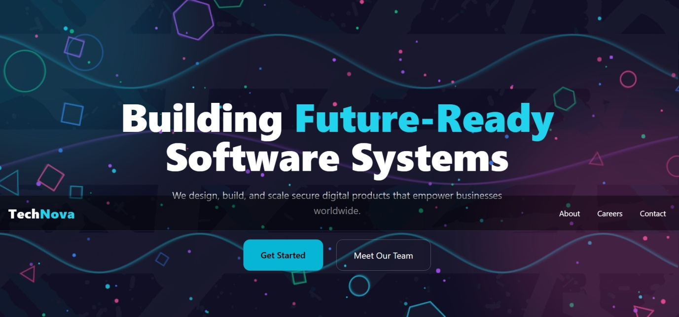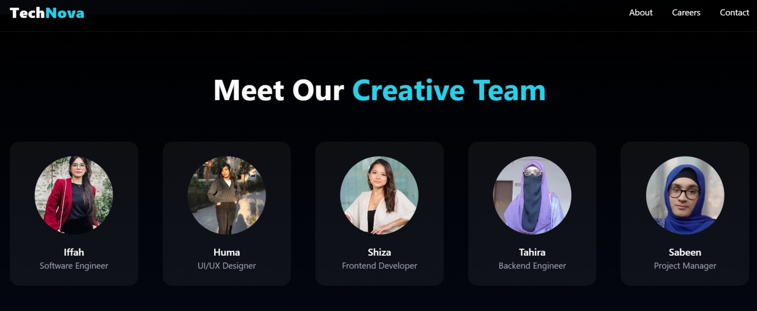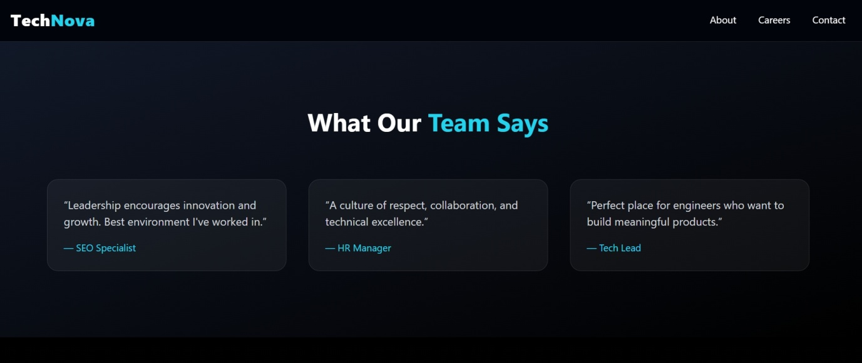

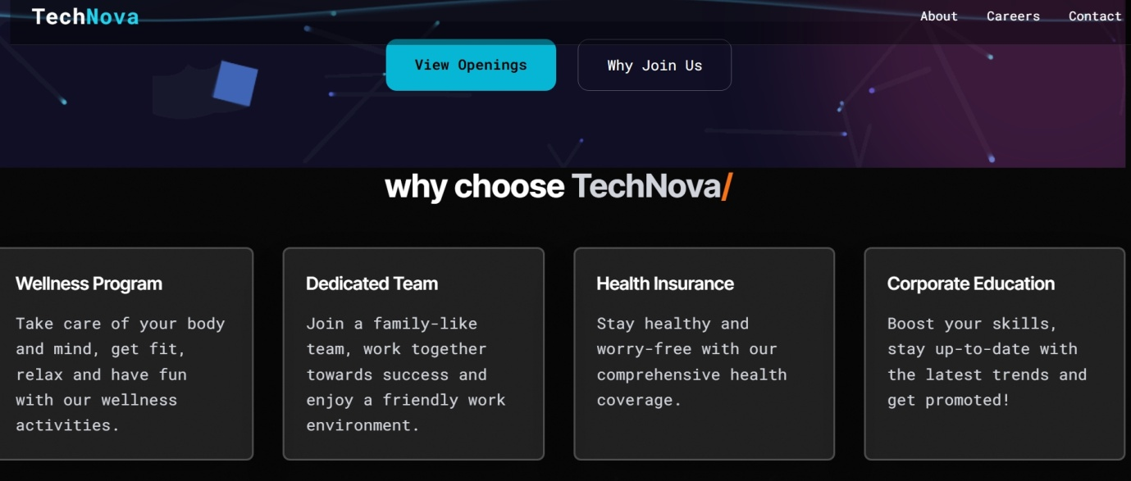

# Design Choices

The TechNova website follows a consistent modern and technology-focused design across all pages to maintain a strong and professional brand identity. A unified visual style is applied throughout the website to ensure clarity, usability, and a seamless user experience.

## Color Scheme

A dark-themed color palette is used across the entire website, primarily consisting of dark navy and black backgrounds. White text is used for primary content to ensure high readability, while cyan accents are consistently applied to highlight headings, icons, links, and call-to-action buttons. This color consistency reinforces brand recognition and improves visual hierarchy on all pages.

## Typography

Sans-serif fonts are used throughout the website to maintain a clean and modern appearance. Headings are bold and prominent to clearly distinguish sections, while body text remains simple and readable. Font sizes are kept consistent across pages to ensure uniformity and visual balance.

## Layout Consistency

All pages follow a structured layout with a fixed top navigation bar, allowing users to easily access different sections of the website. Content is arranged using grid-based layouts, ensuring proper alignment, spacing, and responsiveness. Adequate white space is maintained to prevent visual clutter and enhance readability.

# Page-Specific Design Considerations

* **Home Page:** Features a centered hero section with a strong headline, background visuals, and clear call-to-action buttons to immediately engage users.
* **Services Page:** Uses card-style sections and icons to present services in a clear and organized manner.
* **About Page:** Focuses on textual content with supporting visuals to communicate the company’s mission, vision, and team.
* **Careers Page:** Designed with structured listings to display job opportunities clearly.
* **Contact Page:** Uses a simple and accessible layout with contact information and form elements for user interaction.

## Visual Elements

Abstract geometric shapes, icons, and subtle graphical elements are used throughout the website to represent technology and innovation. These visuals enhance the aesthetic appeal without distracting from the main content.

## User Experience & Responsiveness

The website is designed to be responsive, ensuring proper display on desktops, tablets, and mobile devices. Interactive elements such as buttons and links are clearly distinguishable, improving usability and navigation across all pages.

# Assets Used

|  |  |
| --- | --- |
| Assets | Source |
| Icons | Font Awesome |
| Fonts | Google Fonts |
| Data | Self-created startup mock data |
| Images | Unsplash |

# How to Run / Publish the Website

## Steps:

1. Download the project folder
2. Open index.html in a browser
3. To publish, upload files to GitHub Pages or Netlify

Live Website URL:  
<https://github.com/iffafarhan85-sudo/Tech-Company>

# Excel Sheets

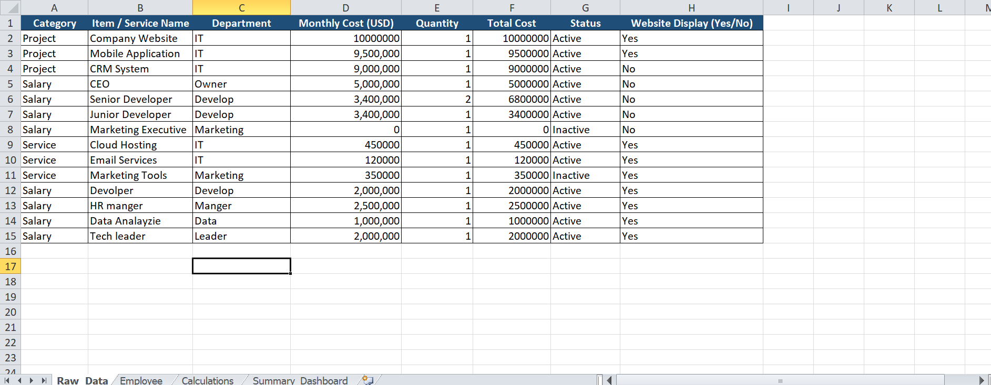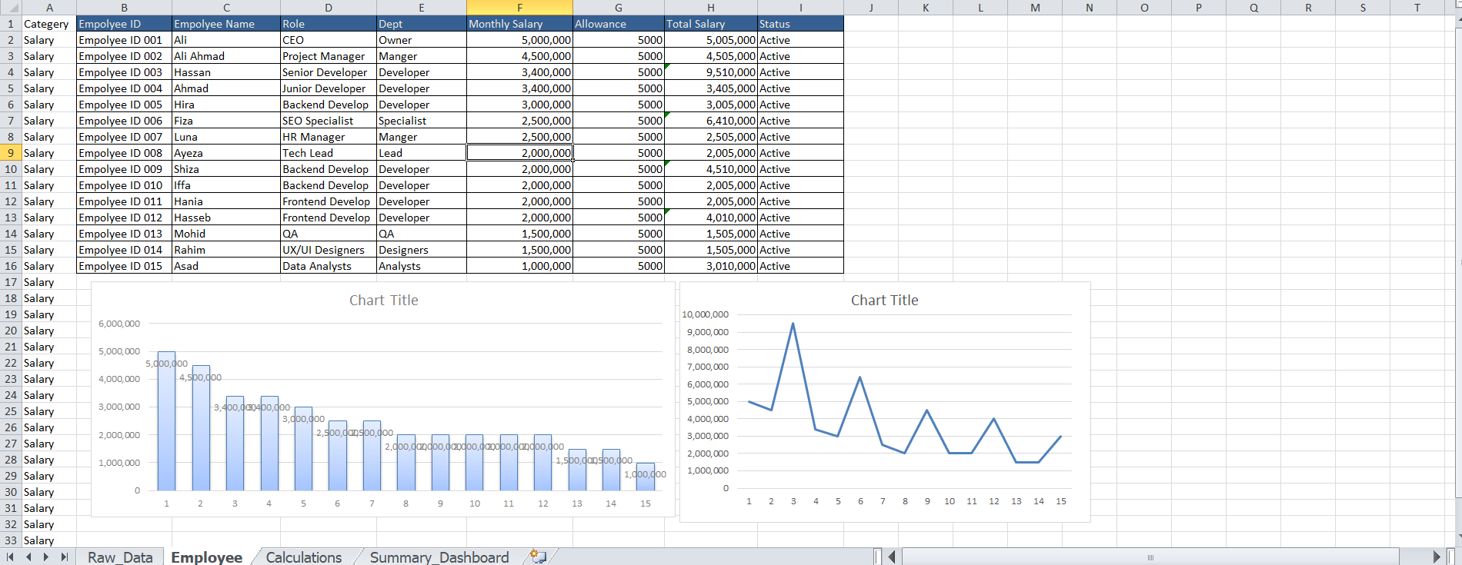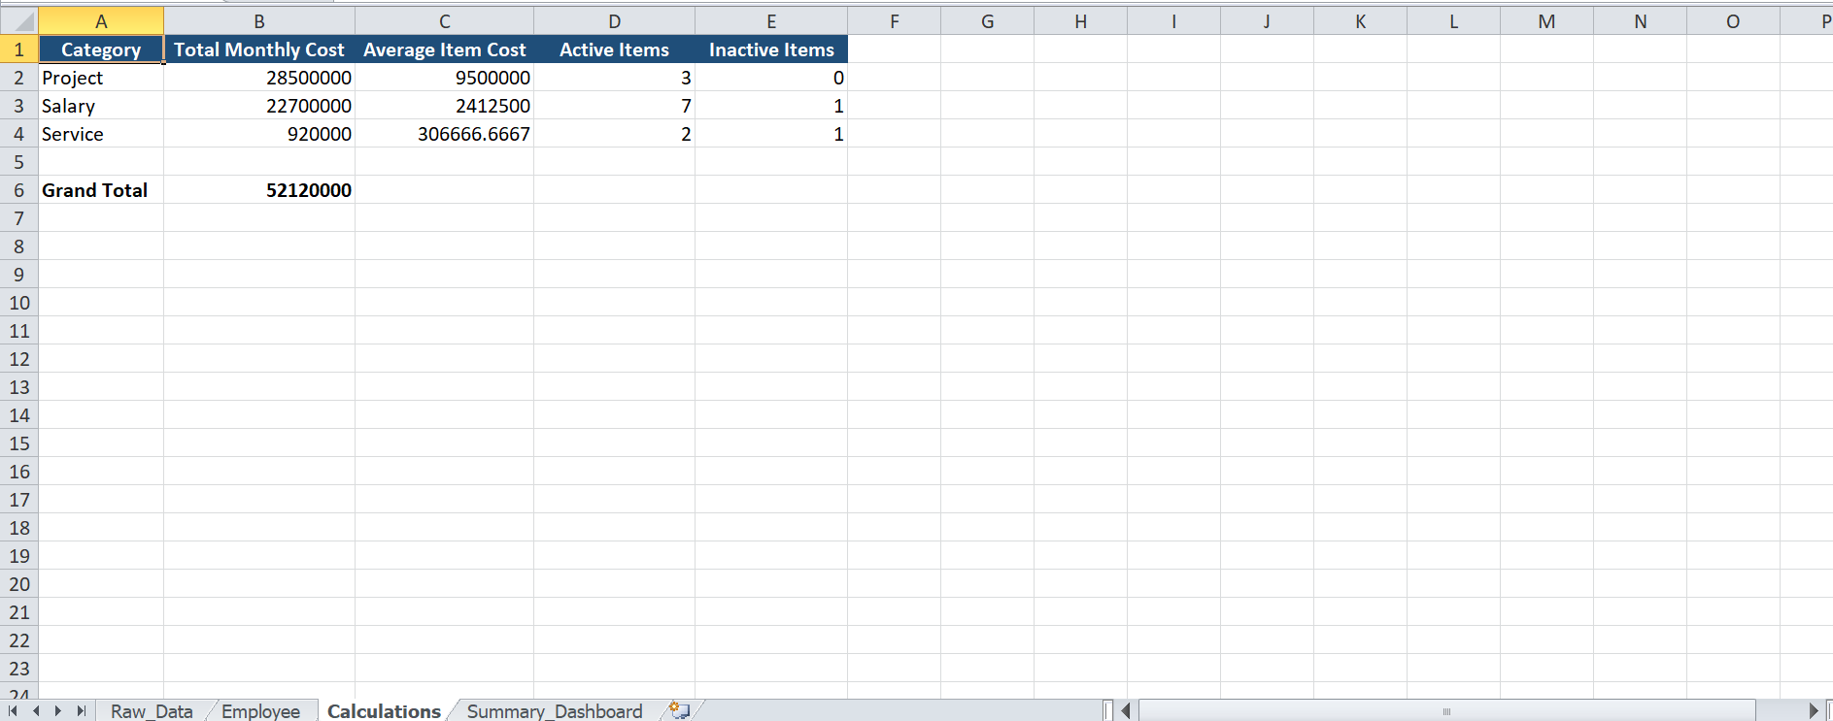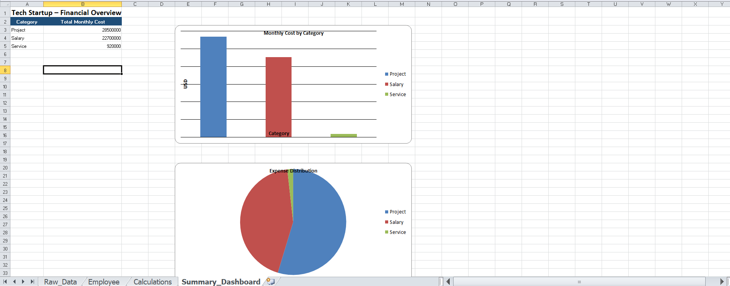

# Reflection

This project helped us understand how web design, documentation, and data

quantification are interconnected. I learned how consistent data presentation improves project credibility. Future improvements could include backend integration, user authentication, and real-time analytics.

# LinkedIn Screenshots

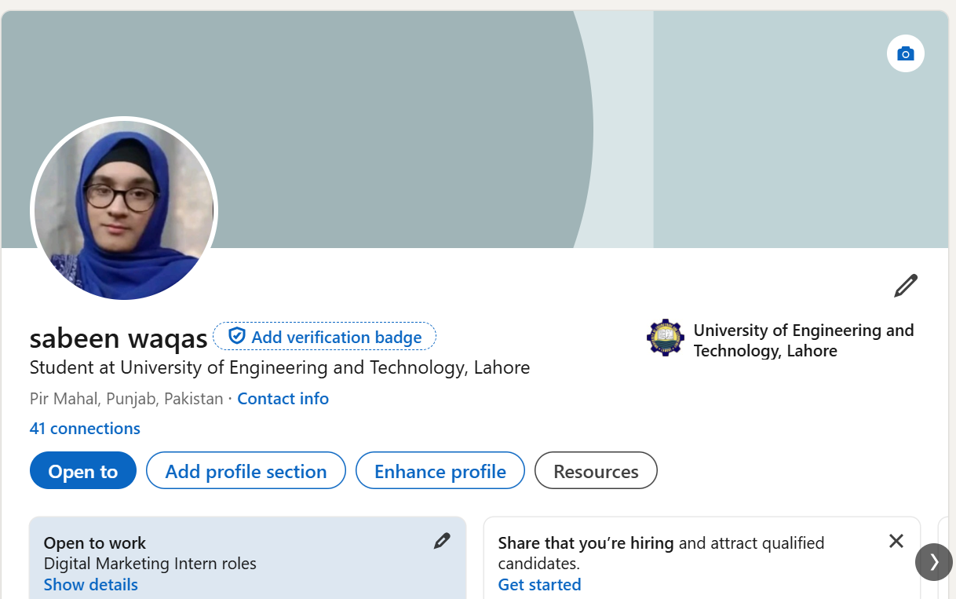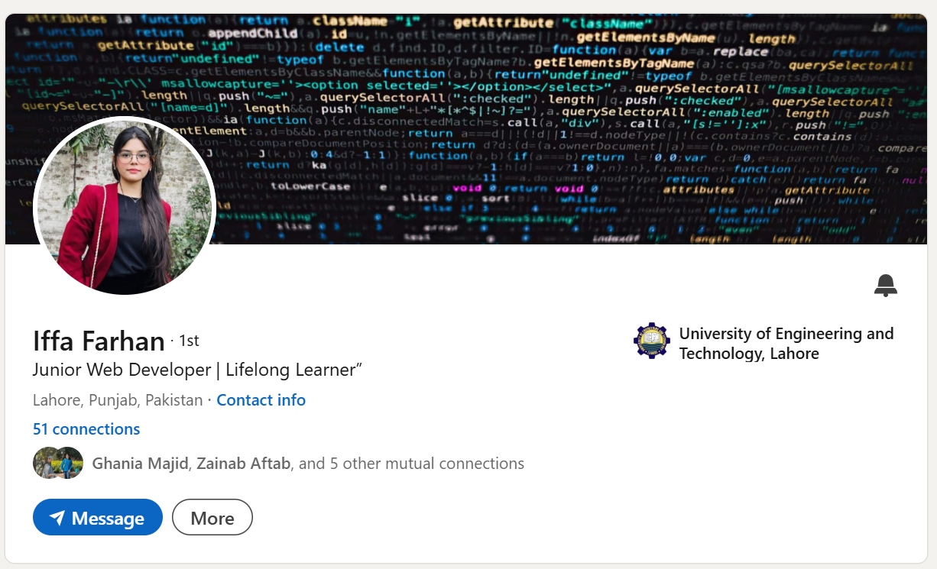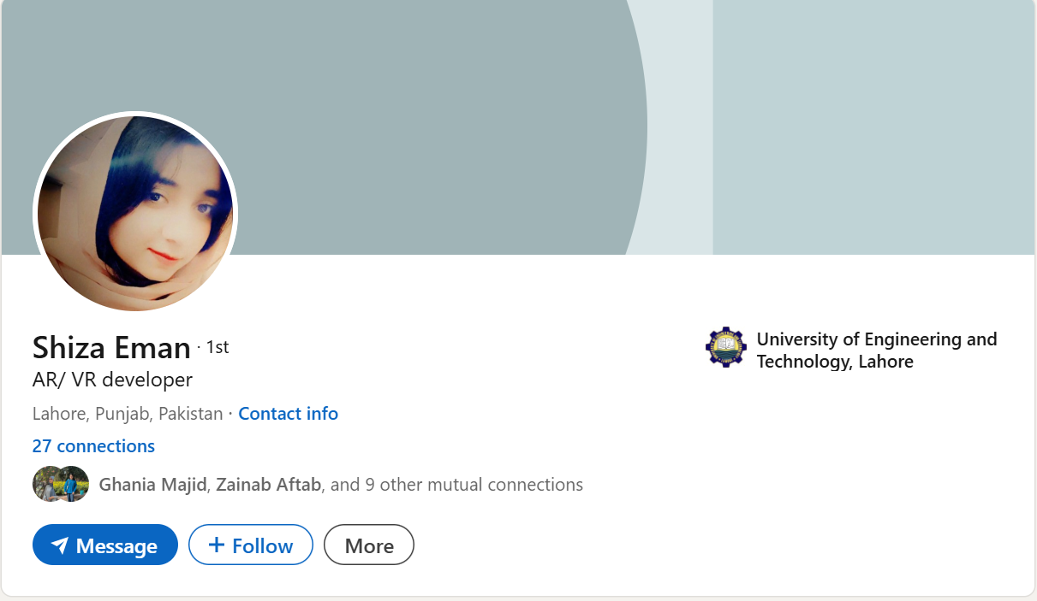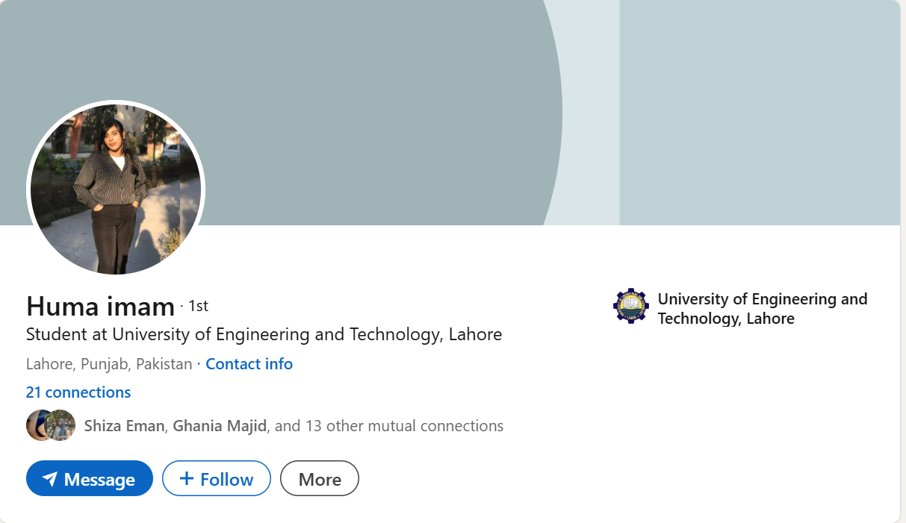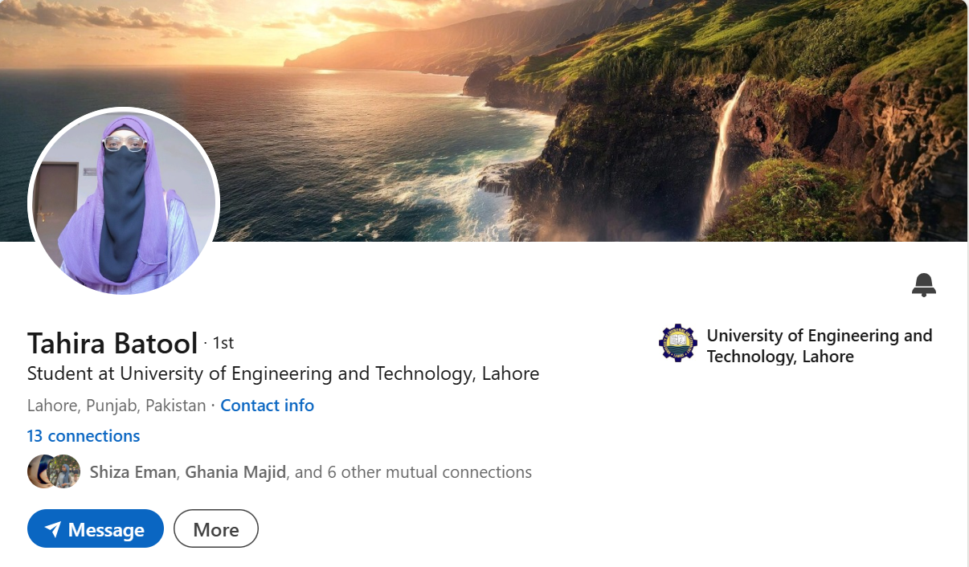

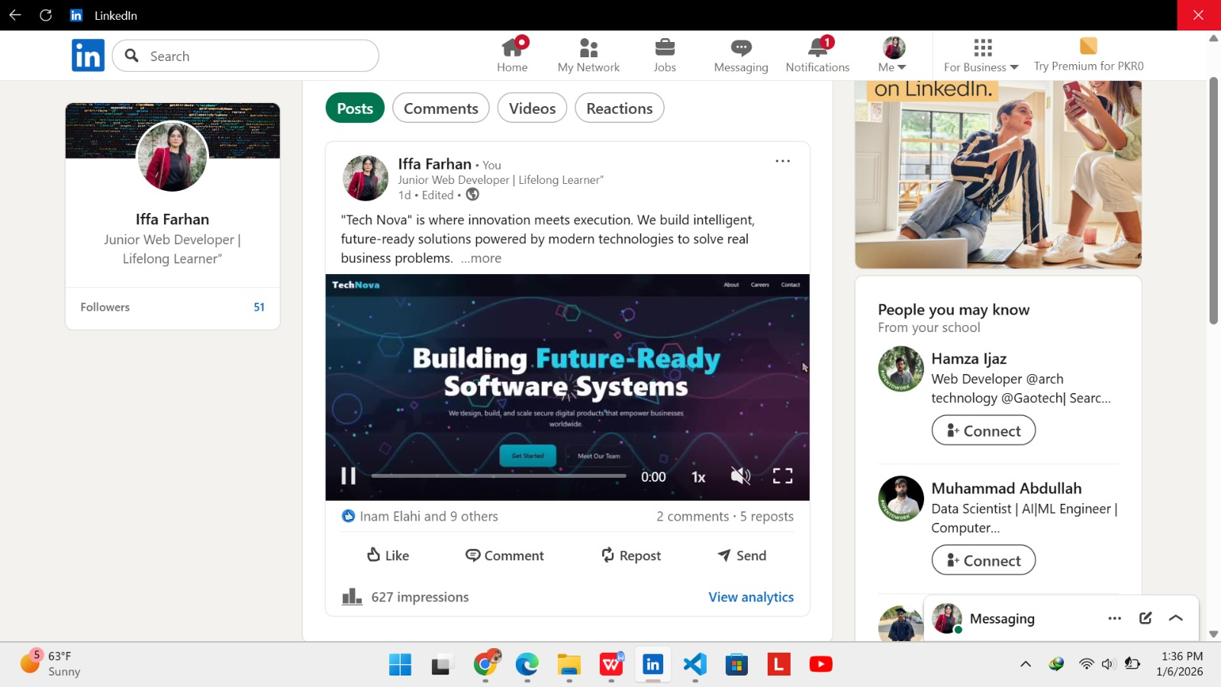

# POWERPOINT KEY SLIDES

